Introduction_to_Python_for_Kids_c02

**CHAPTER 2 Let’s Install Python!**

In this chapter, we will take a deeper look into what programming is and how it is used to control various gadgets. We will also look at installing Python in our system. Let us get started!

**Speak the computer’s language**

Language is used for communication between two or more people, am I right? But if someone talks to you in a language you do not know, would you understand them? Of course not. I would not either!

Similarly, your computer cannot understand languages it does not speak. So, if you just look at your computer and command it to open the paint program in plain English, it will not understand you. If you talk to it in a language it understands, on the other hand, you will certainly get a response.

Programming languages are languages computers understand. Python is one of them. If you want your computers or mobile phones or GPS or tablets to do something, you need to give them instructions.

When you click the paint app’s icon, how does your device know that you have actually clicked it? How does it open that exact app and not something else? That is because a programmer probably wrote a bunch of lines of code that says that when someone clicks the paint icon, the paint app should open. If they changed the code and wrote that clicking that icon should open the Google Chrome browser, then that is what would happen.

Therefore, a programmer’s job is extremely important. They make the devices work. They create the device’s brain that makes actions possible. Without their code, the devices you use every day would just be a mass of plastic, chips, and wires, and nothing else. So, if you learn to speak the computer’s language, you can give your computer, or any gadget really, instructions like these too. Once you get good at programming, you can create apps like the paint app or games like Minecraft.

**Get started – install Python**

Now you know what programming is. It is just a set of instructions you give a gadget/device to make it do what you want it to do. Shall we start programming then? Python is one of the easiest programming languages out there, so that is exactly what we are going to learn in this book.

Before you write Python programs though, you need to install it in your laptop or computer. Remember how I said your computer needs to speak the language to understand what you are saying? Right now, your computer probably does not speak the Python language. That is because Python is not installed in it. Once you install it, your computer will learn the language in seconds (yes, it is that fast!), and then when you give it instructions in Python, it’ll understand you and react accordingly. It is magic! I will give you step-by-step instructions on installing and running Python on your system, so just follow along with me, alright? I will give separate instructions for Windows as well as Mac, so skip to the one you have on your device.

**Installing Python on a Windows computer**

Let us look at how to download and install Python on a Windows device first. These steps work for Windows versions 7 and higher.

**Download Python**

1. Open the following link on your browser: www. python.org/downloads/.

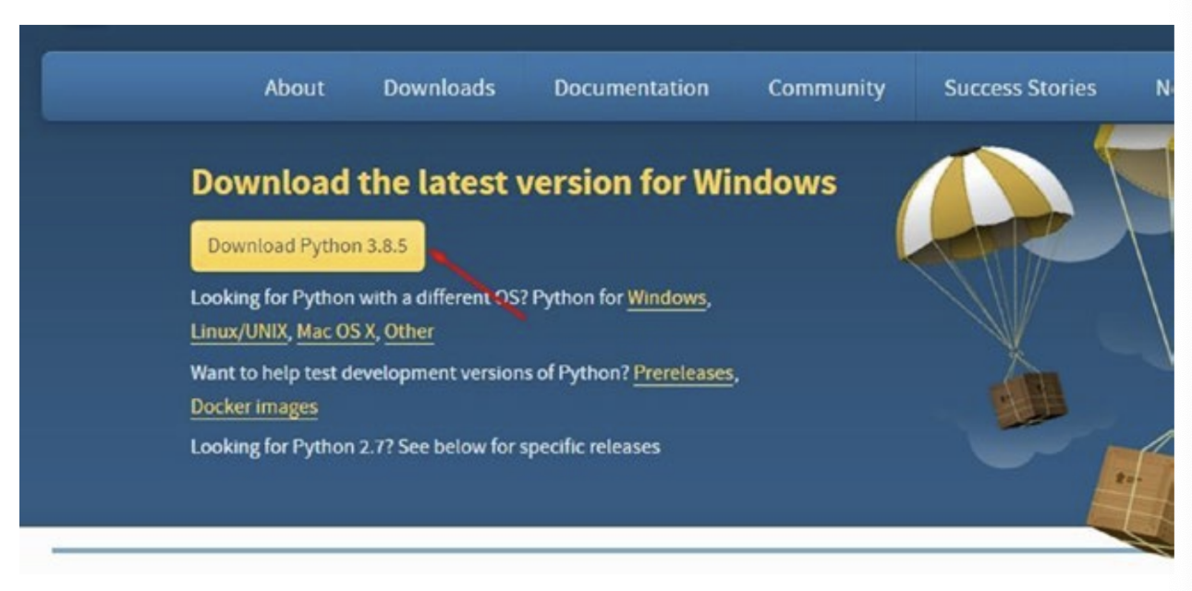

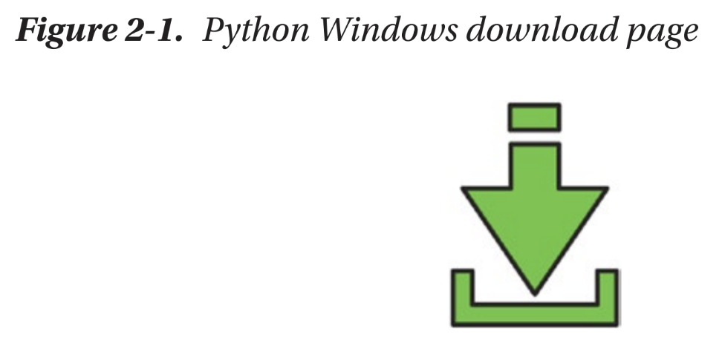

2. Click the download button (look at the arrow in Figure 2-1) to download the Python installer. Remember how I told you that coding was magical? You will see that in action now. When you opened the page, it knew you were using a Windows computer without you having to tell it.

I have downloaded Python 3.8.5 as of writing this book, but you might be downloading a newer version. Do not worry about that. Go ahead and download the latest version.

**Install Python**

It knows you have a Windows computer, so you will now have to install the Windows version of Python. Let us do that:

1. Open the .exe file you just downloaded. You will see a popup like Figure 2-2.

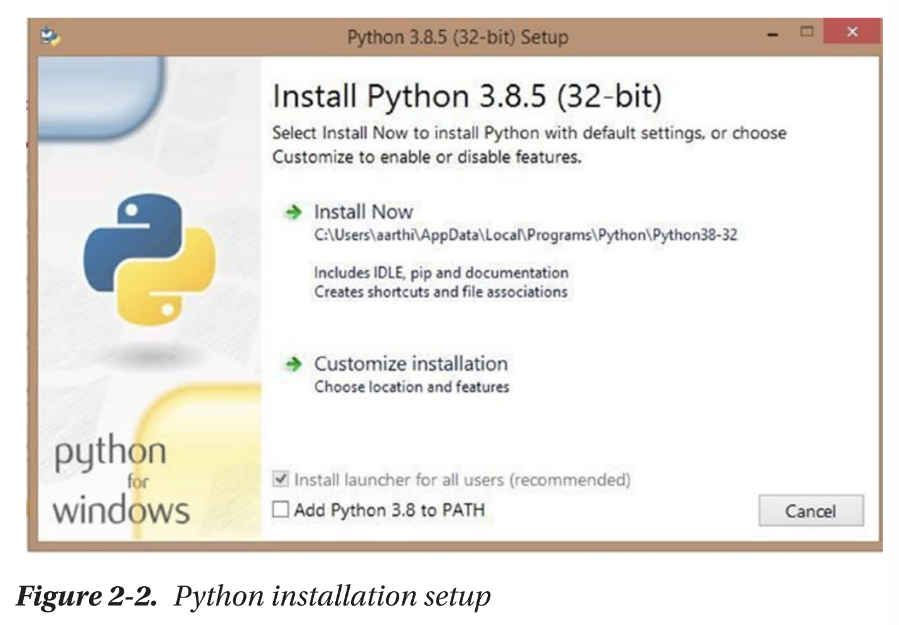

2. Do not forget to click the checkbox that says “Add Python 3.8 to PATH” (Figure 2-3). Figure 2-2. Python installation setup Figure 2-3. Add Python to PATH

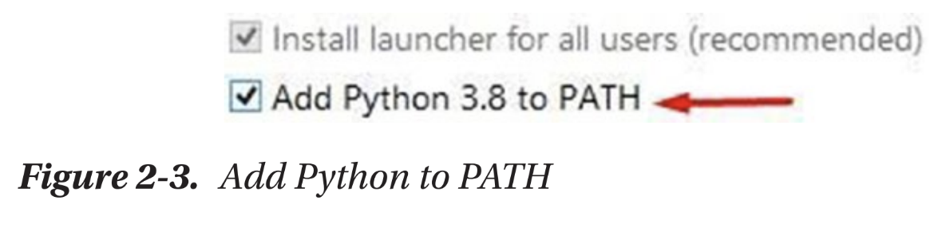

3. Once you have ticked the box, click install now. The installation will start, and it will look something like Figure 2-4.

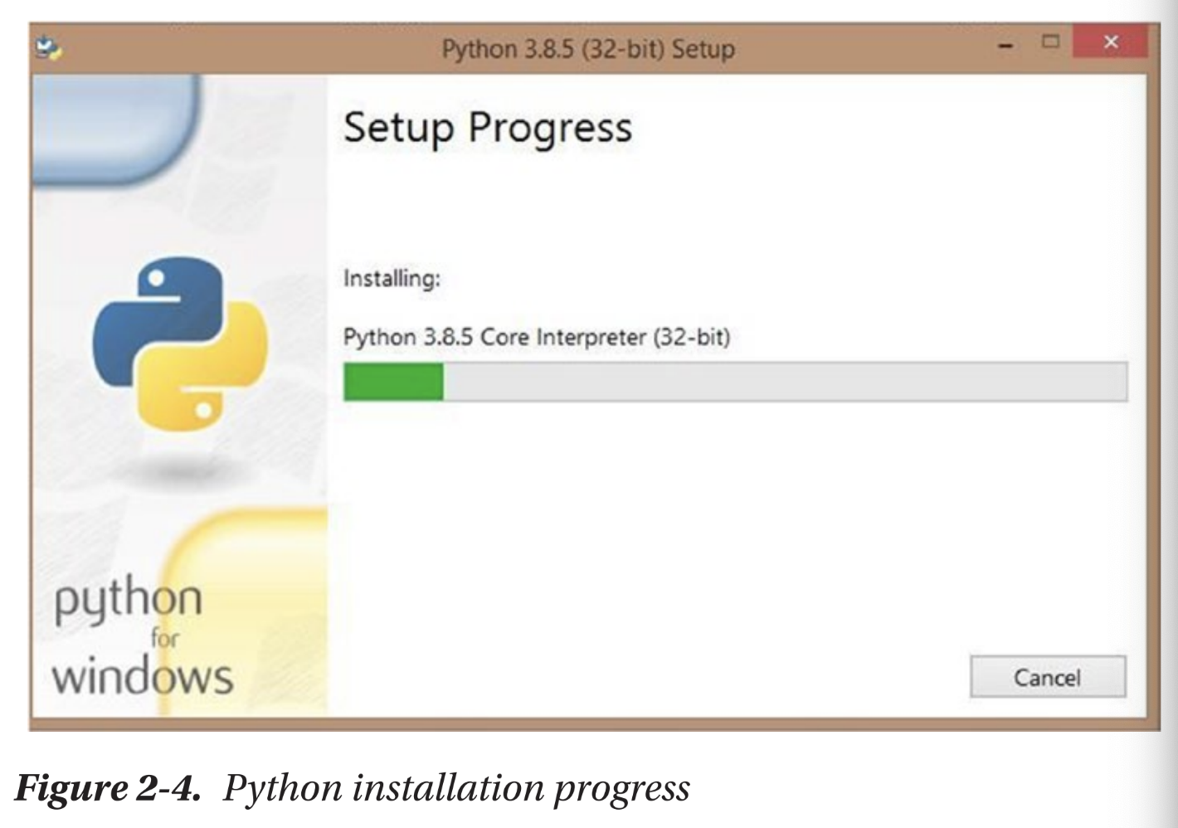

4. Wait until the green bar reaches the end, and you will see a message that says “Setup was successful” (Figure 2-5).

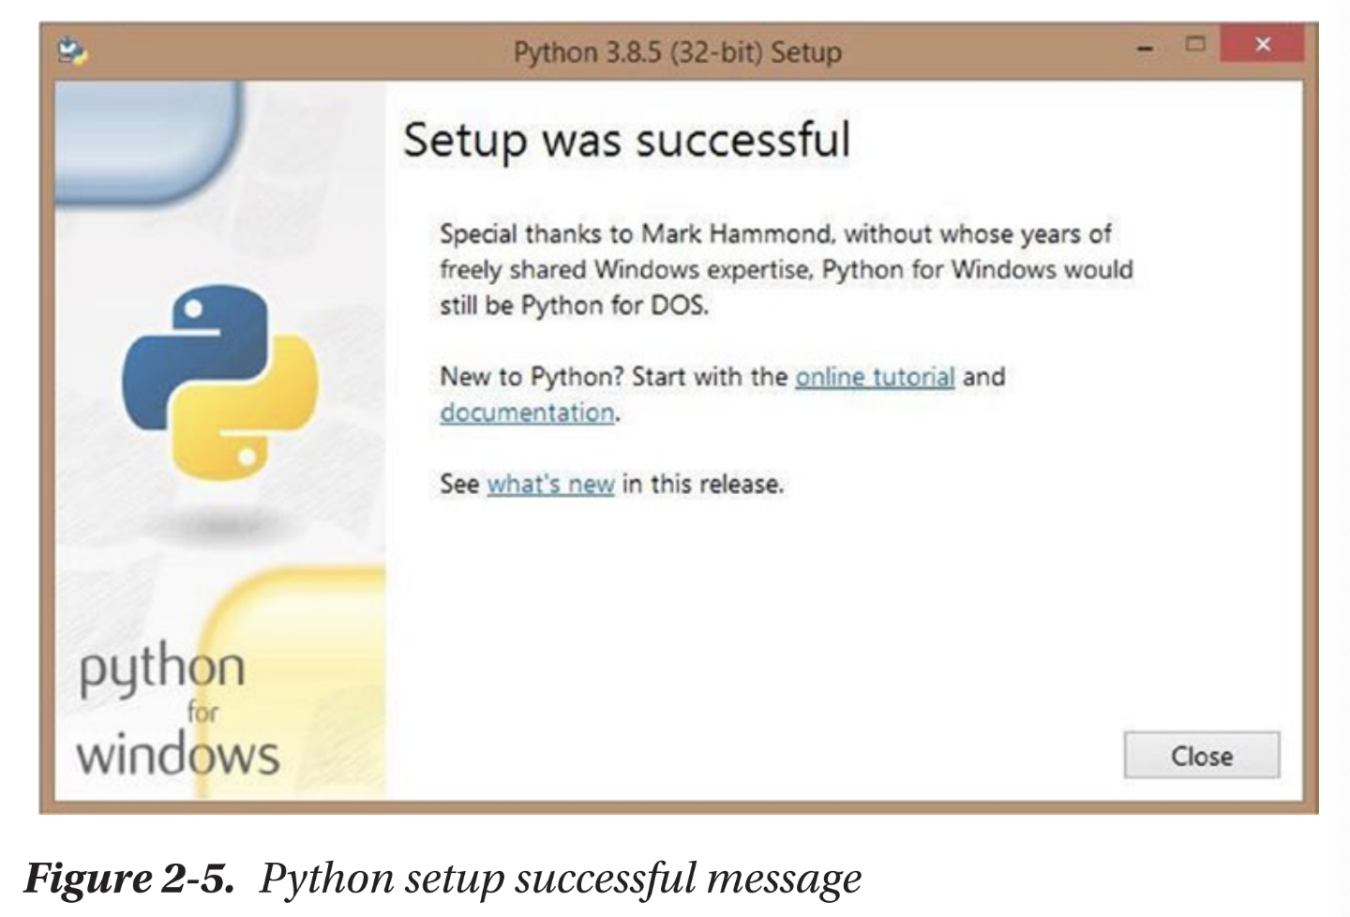

5. Press the Close button, and you are done installing Python on your computer. Hurray! �

**Installing Python on a Mac device**

Let us look at how to download and install Python on a Mac device next. If you have a Windows computer, and you have already installed Python following the steps in the last section, you can skip this section. Python usually comes preinstalled in any Mac device, but chances are you have an older version of Python in your system. It never hurts to have the latest version of any software, so let us update our Python, shall we?

**Download Python**

1. Open the following link in your browser: www. python.org/downloads/ (Figure 2-6).

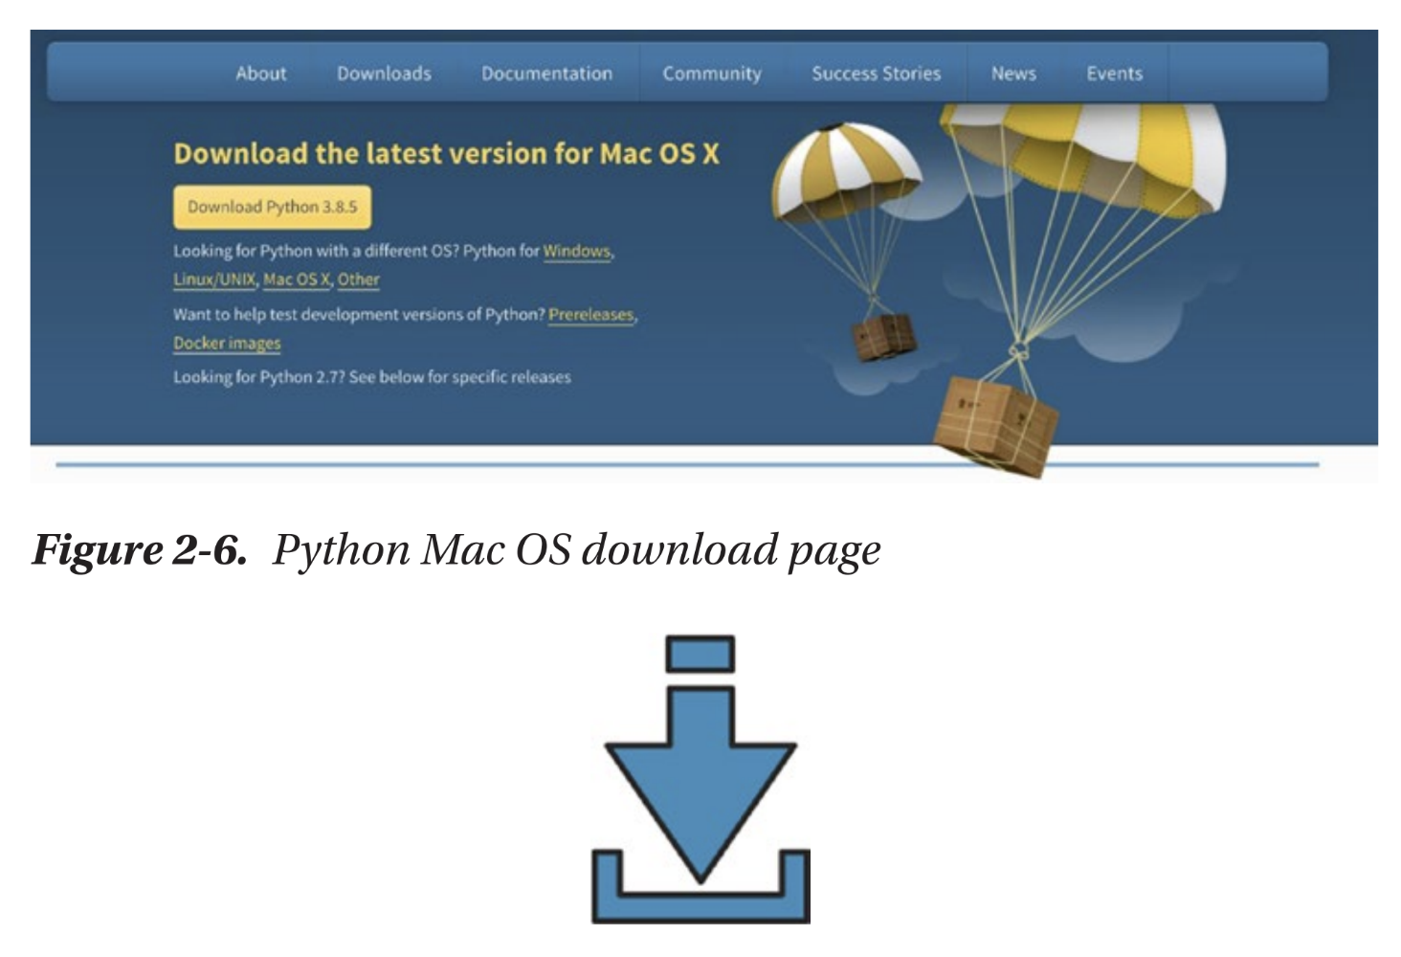

2. Click that big yellow download button to download the Python installer. Remember how I told you that coding was magical? You will see that in action now.

Did you notice that when you visited the download page from your Mac device, it automatically says “Download the latest version for Mac OS X”? That is because the Python website’s code read which operating system (Windows, Mac, etc.) you are using and gave you the correct version to download automatically. Cool, right? Your package will download as in Figure 2-7. Figure 2-6. Python Mac OS download page Figure 2-7.

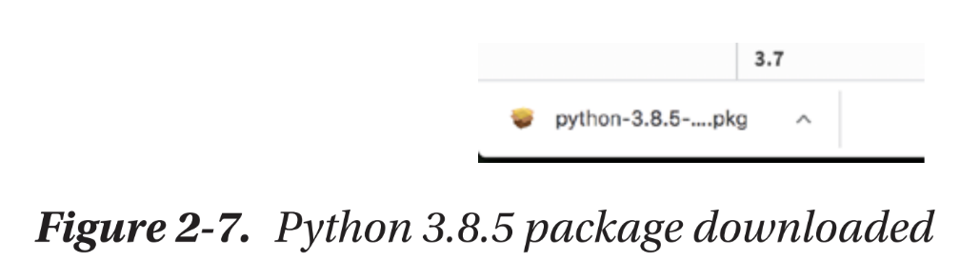

I have downloaded Python 3.8.5 as of writing this book, but you might be downloading a newer version. Do not worry about that. Go ahead and download the latest version.

**Install Python**

1. Open the installer and you will see a screen like Figure 2-8.

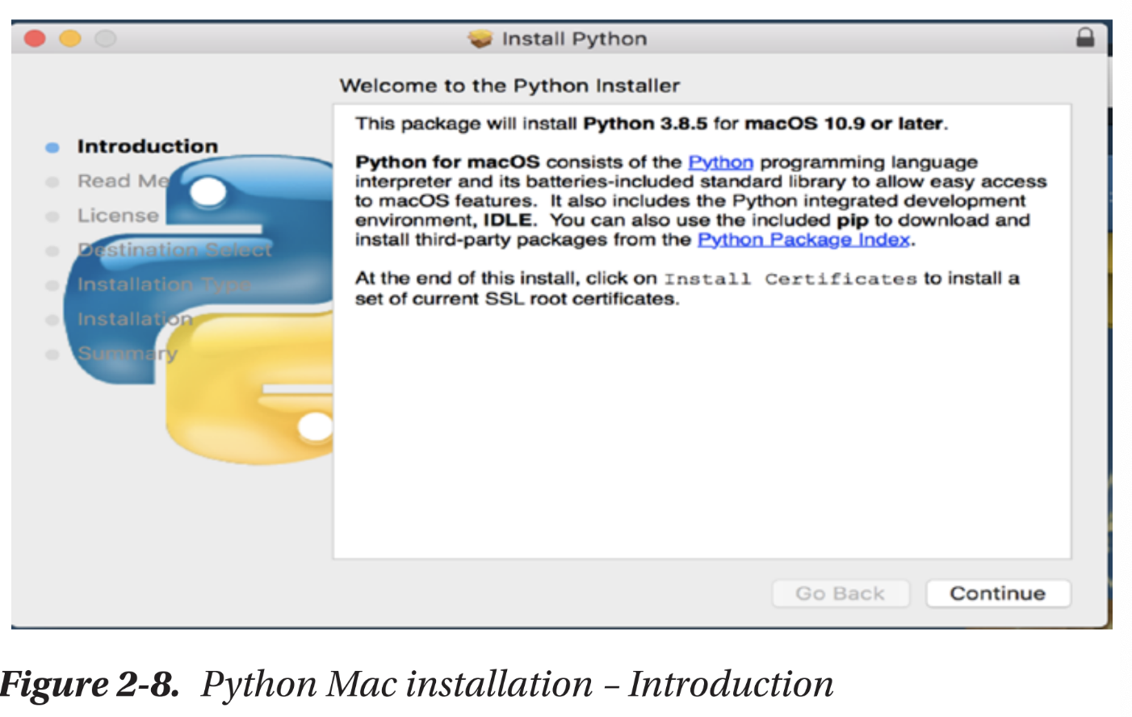

2. Click Continue, and you will get the following page (Figure 2-9).

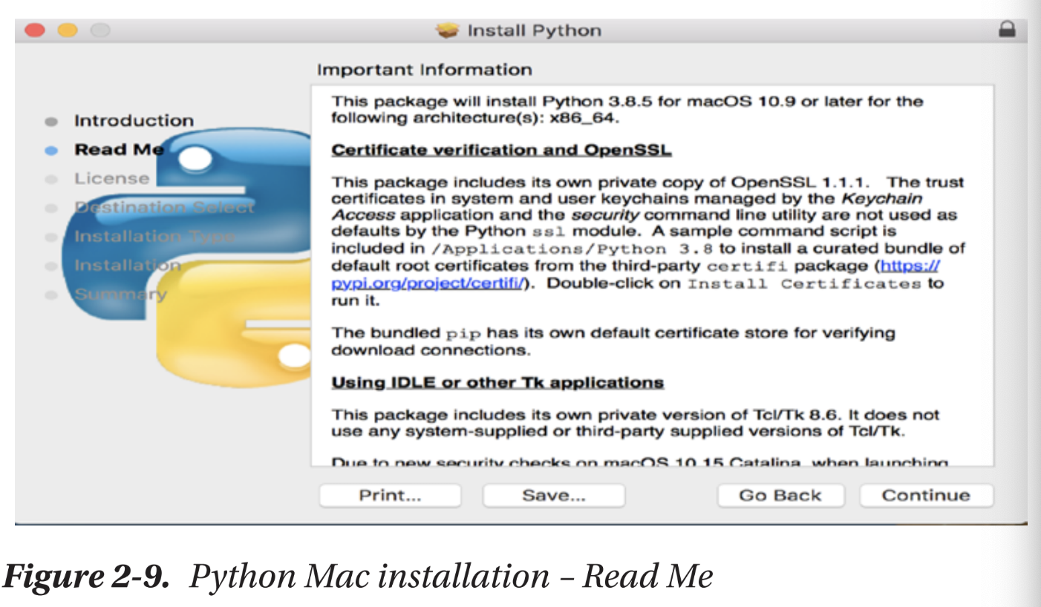

3. Click Continue again, and you will get the following page (Figure 2-10).

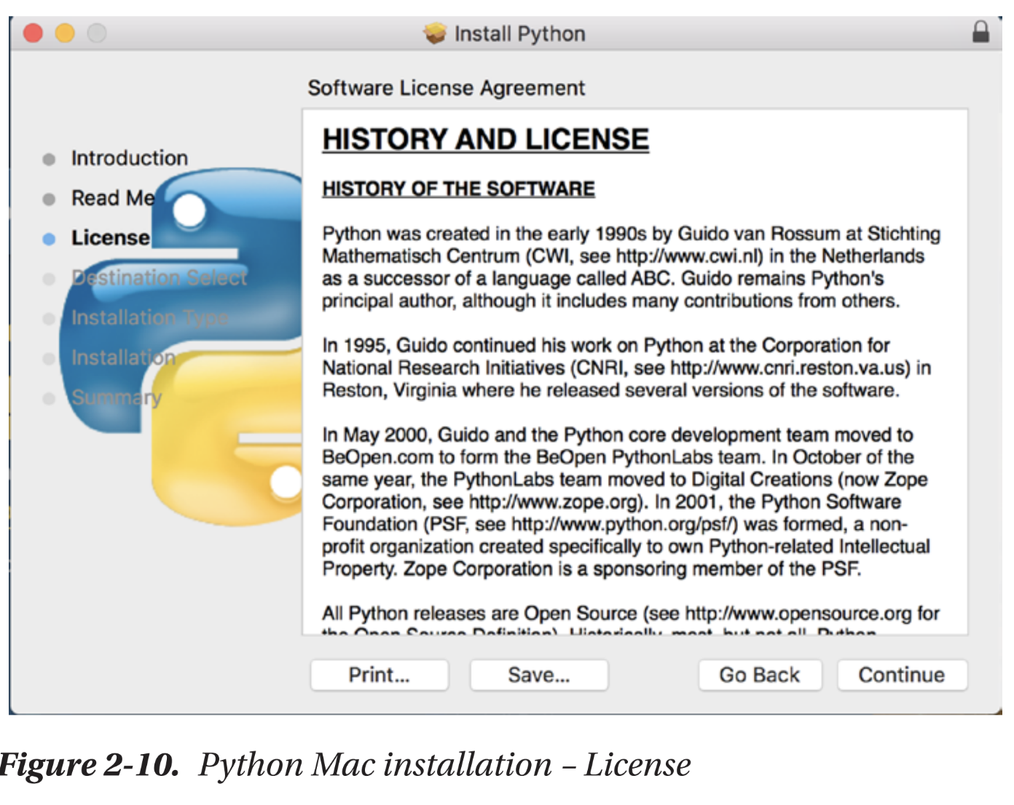

4. Click Continue again (Figure 2-11).

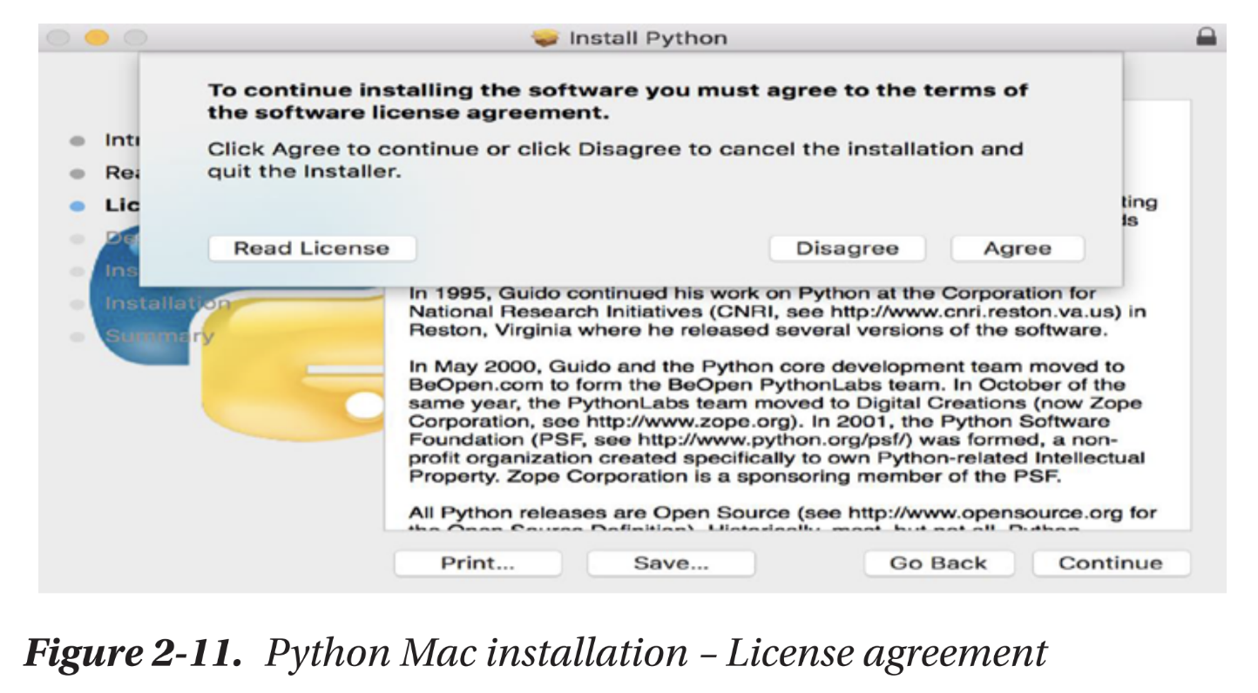

5. While you are at the license page, you might get a popup like the preceding one. Click Agree, and you will get the Installation Type page (Figure 2-12).

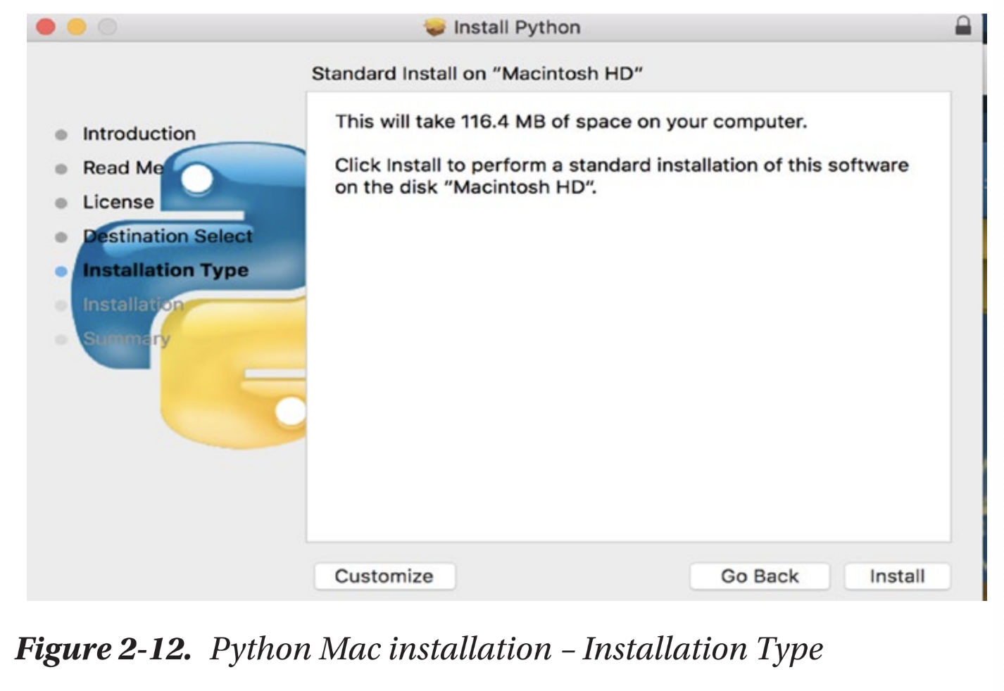

6. We are almost there! Click the Install button, and your installation should start immediately. In certain cases, you might see a popup that asks for your username and password like the following one (Figure 2-13).

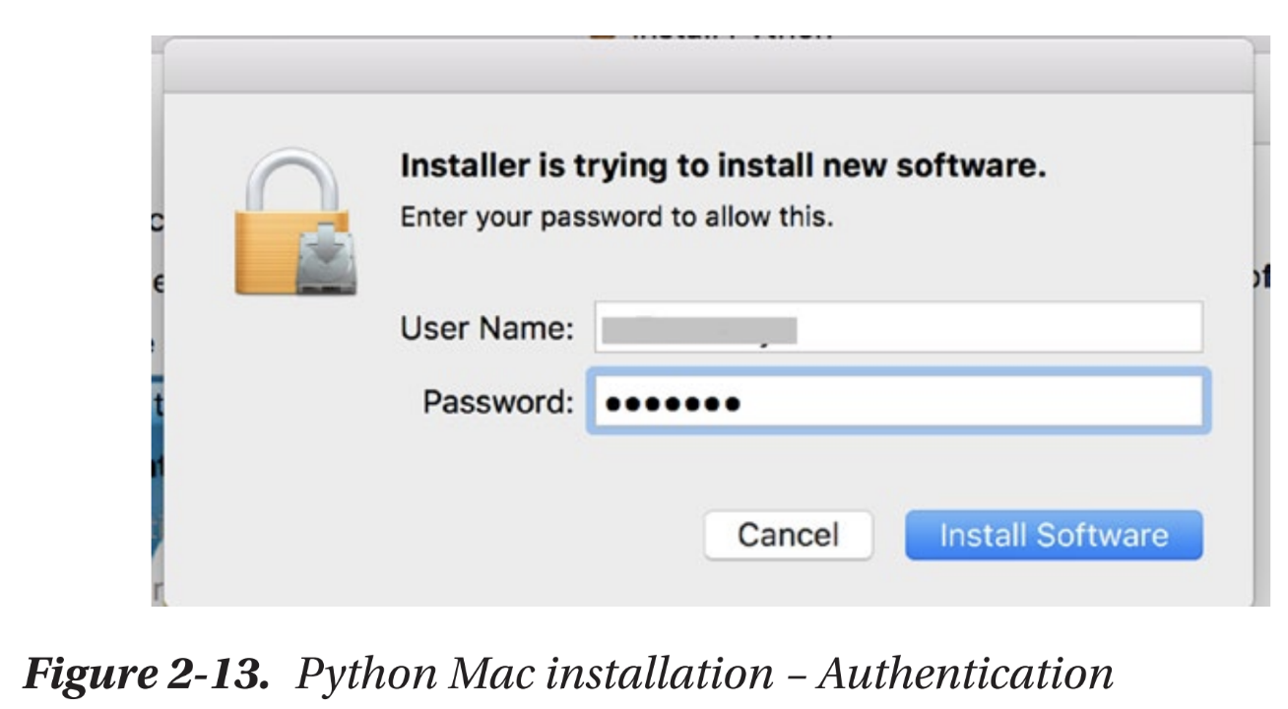

7. Enter your Mac username and password and you’ll be good to go. If you’re using your parents’ system, call them to help you with this step.

Once you’ve finished this step, you should see the installation start (Figure 2-14).

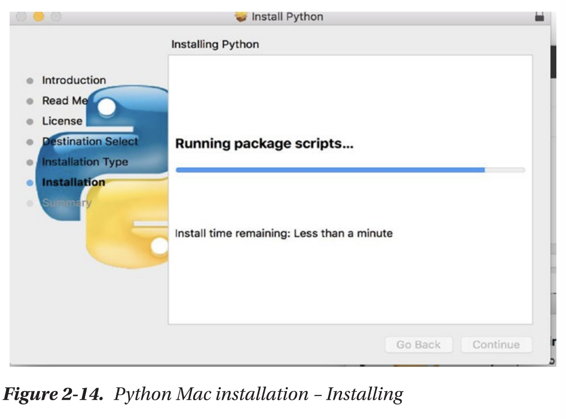

8. Wait till the blue bar runs till the end. It shouldn’t take more than a few minutes. Once done, your Python package should open up (Figure 2-15).

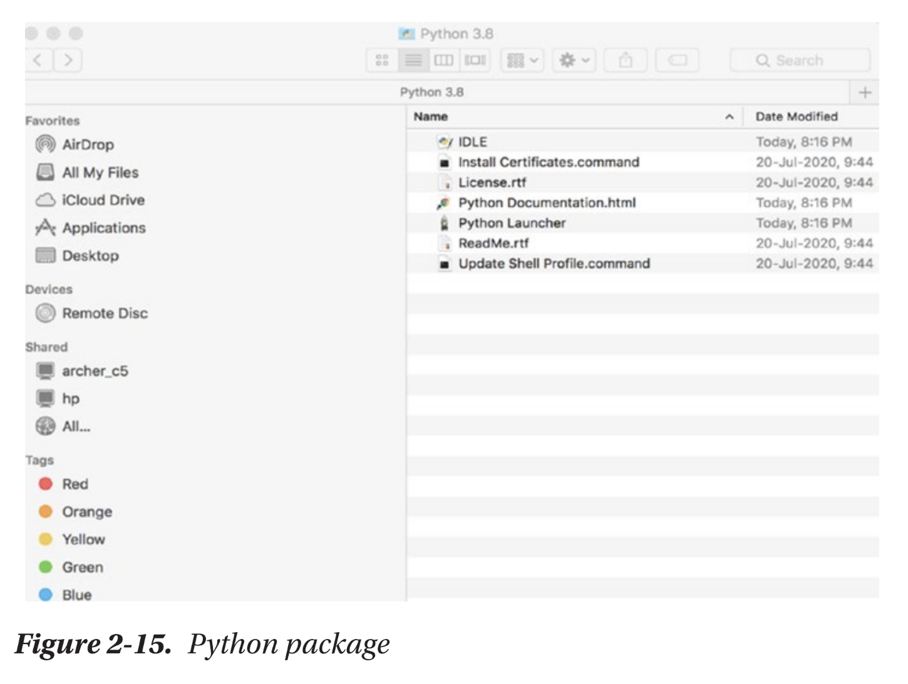

Congrats! You’ve downloaded Python! It wasn’t as hard as you thought, was it? Let’s have fun with it in the next section. �

**Summary**

In this chapter, we learned how to download and install Python in both Mac and Windows. In the next chapter, let us look at creating our very first program in Python.